Lab Report No 2

Introduction to OpenCV Library w.r.t. Image Processing Basic Commands
Digital Image Processing



Submitted By:
[Huzaifa Shahbaz]
[21-CE-009]
[Aqsa Shah]
[21-CE-039]

Submitted to:
Engr. Hareem Khan
Dated:
3rdOct,2024

Department of Computer Engineering,
HITEC University, Taxila
Lab Task No 1:

Solution:
Brief description (3-5 lines)
Now create a generic code that creates a border around any landscape image as shown below. The length of right and left borders must be 10% of the original horizontal length of the image. The length of upper and lower border must be such that the image now have same number of rows as columns. Save the image.
The code
from PIL import Image
# Use a raw string to avoid issues with backslashes in the file path
image_path = r"D:\BSCOMPUTER ENGINEERING\4th YEAR OF COMPUTER ENGINEERING\7th SEMESTER\DIGITAL IMAGE PROCESSING\PROGRAMS OF DIGITAL IMAGE PROCESSING\Screenshot 2024-10-09 091542.jpg"
# Load the image
image = Image.open(image_path)
# Get the original dimensions
original_width, original_height = image.size
# Calculate the borders
left_right_border = int(0.10 * original_width)
# Calculate the required final size to make it a square (rows = columns)
final_size = original_width + 2 * left_right_border
# Calculate the upper and lower borders to make it a square
upper_lower_border = (final_size - original_height) // 2
# Create a new image with the final size and black borders
new_image = Image.new("RGB", (final_size, final_size), (0, 0, 0))
# Paste the original image in the center with borders
new_image.paste(image, (left_right_border, upper_lower_border))
# Save the new image
new_image.save("image_with_borders.jpg")
The results (Screenshot)
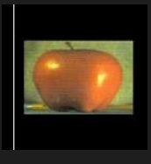
Lab Task No 2:

Solution:
Brief description (3-5 lines)
Using the following formula f (i, j) = sin (2 π f (i + j)) where i are j indices of a pixel, draw an image with different frequencies (input from user).
The code
import numpy as np
import matplotlib.pyplot as plt
# Function to generate the image with sine wave pattern
def generate_sine_image(frequency, size=256):
image = np.zeros((size, size))
for i in range(size):
for j in range(size):
image[i, j] = np.sin(2 * np.pi * frequency * (i + j))
return image
# Function to display the images with different frequencies
def plot_images(frequencies, size=256):
plt.figure(figsize=(15, 5))
for idx, freq in enumerate(frequencies):
plt.subplot(1, len(frequencies), idx + 1)
image = generate_sine_image(freq, size)
plt.imshow(image, cmap='gray', extent=(0, size, 0, size))
plt.title(f"Frequency = {freq}")
plt.axis('off')
plt.show()
# Ask user for frequencies
frequencies = [float(x) for x in input("Enter frequencies separated by spaces: ").split()]
# Generate and display the images
plot_images(frequencies)
The results (Screenshot)
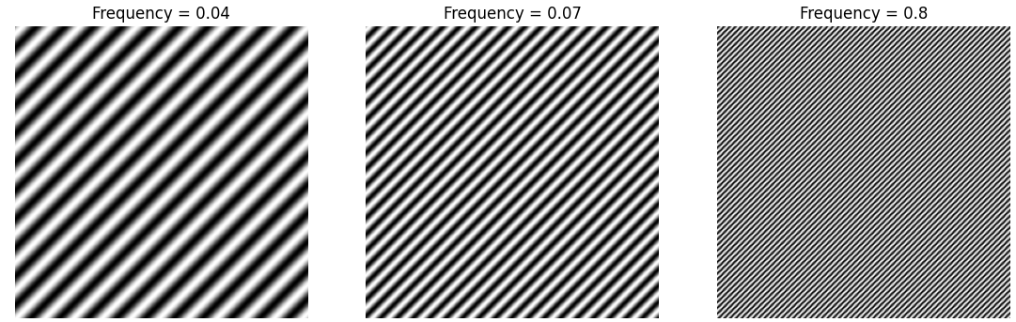
Lab Task No 3:

Solution:
Brief description (3-5 lines)
Write Python functions that can create the images given below. Code them in such so that the size of the image itself are entered by the user.
The code
from PIL import Image, ImageDraw
import math
def create_image1(size):
img = Image.new('RGB', (size, size), (255, 255, 255))
draw = ImageDraw.Draw(img)
draw.rectangle([(0, 0), (size-1, size-1)], outline=(0, 0, 0))
img.save('image1.png')
def create_image2(size):
side_length = size // 2
img = Image.new('RGB', (size, size), (0, 0, 0))
draw = ImageDraw.Draw(img)
draw.rectangle([(side_length//2, side_length//2), (size-side_length//2-1, size-side_length//2-1)], fill=(255, 255, 255))
img.save('image2.png')
size = int(input("Enter the size of the image: "))
create_image1(size)
create_image2(size)
The results (Screenshot)

IMAGE 1.PNG IMAGE2 .PNG
Conclusion
In conclusion, The OpenCV library provides essential image processing commands, including image loading, manipulation, and transformations. Its functionality includes image filtering, edge detection, and feature extraction, supporting diverse computer vision applications. Its accessible API and extensive documentation enable seamless integration into projects, enabling developers to implement image processing solutions efficiently.

